SUPERVISION
Date / time: 13/11/2025

Main issues discussed
1. The main problem with my writing: the text is too dense and compact.
2. Any specialised methodological concept must be clearly defined and illustrated with examples.
3. Viva / Presentation: timing, structure, number of slides, and possible questions.
4. Project adjustments are a way to show independence; if there are none, it is fine not to write anything.

Work shown
- Show my supervisor two draft versions of the RealWorld dataset preprocessing.
My supervisor’s suggestion: write more, explain why it is necessary, and give some examples.
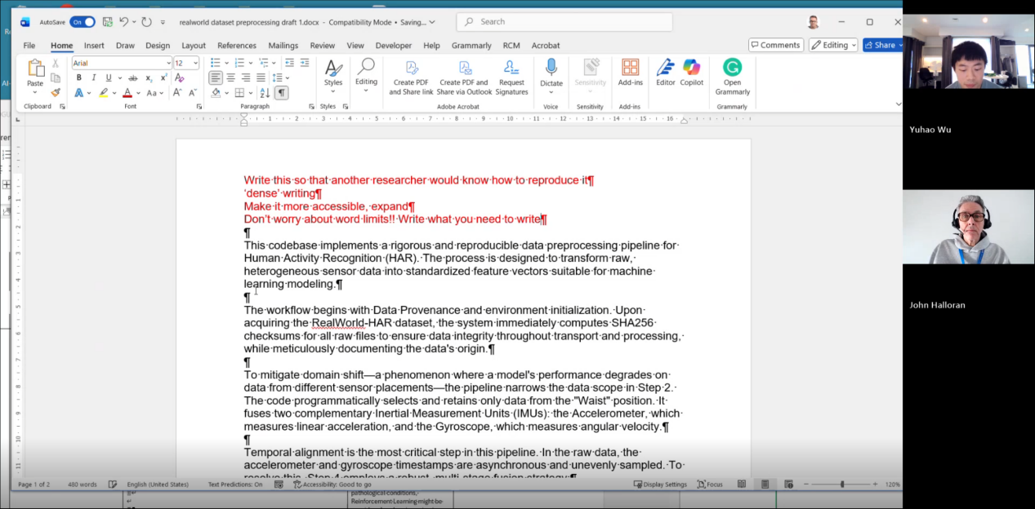

- Experiments presented: I added two state-of-the-art models, DeepConvContext and rTsfNet, as my model baselines. Then, by combining the strengths of rTsfNet, DeepConvContext, and Transformers or some other models, I designed two new models.
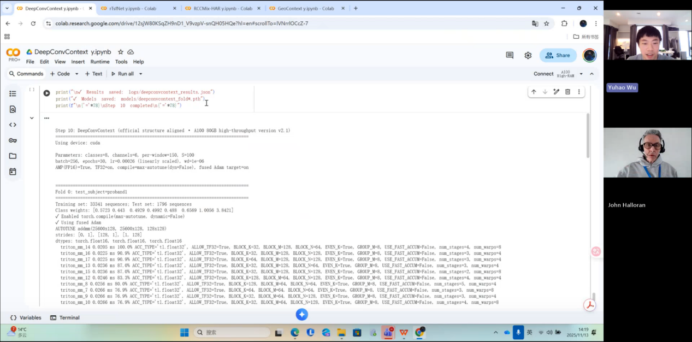

- Show my supervisor my entire experimental workflow.
My supervisor thinks my workload is very heavy and asked whether I am confident I can finish it. My answer was yes.
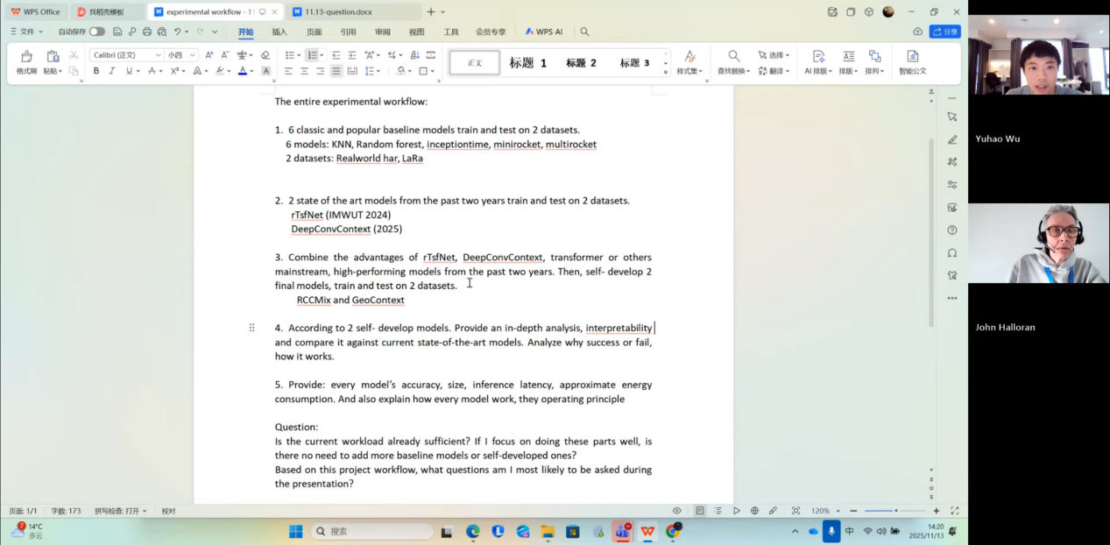

Questions asked; how questions were answered
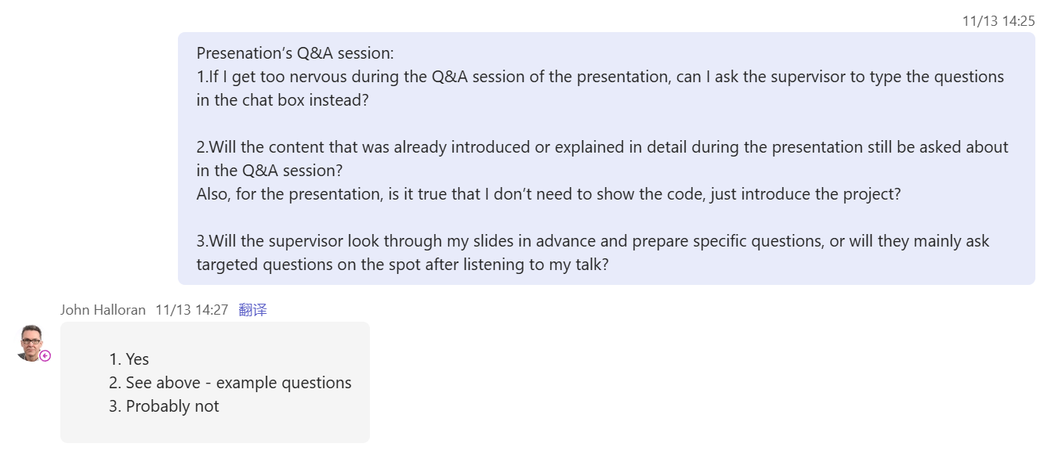

Answer: A 10-minute presentation is very short, so the structure is extremely important, don’t try to cover too much content.
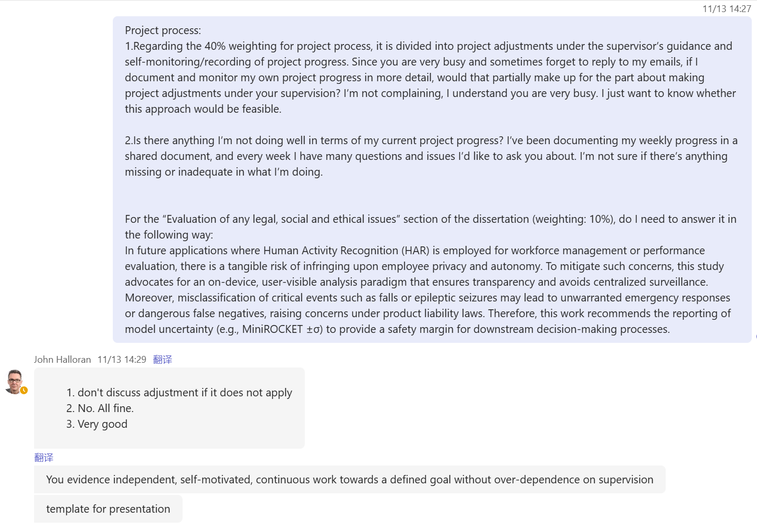

Email


Computing Project
WORK DONE
1. I completed the DeepConvContext code and trained and tested it on the RealWorld dataset.
2. I designed a new model, RCCMix Lightweight.
3. I have written about half of the literature review, up to Chapter 6 on Evaluation Methodology.
4. I successfully modified the code so that, for the LARa dataset, it now runs through all folds automatically instead of using a single-fold mode.
5. I have completed the sensitivity and robustness experiments for MiniRocket.
6. I have organised part of the project process evidence and created a “project_process” folder in GitHub.

Issues and challenges
I only used one variant of DeepConvContext, so the evidential strength is insufficient.

Actions for next week
- Organise the code and upload it to GitHub
- In-depth analysis of RCCMix
- Inference latency code
- Model size code
- Organise the project progress
- Measure the remaining models’ size, inference latency, and energy consumption

Evidence
Part 1
https://livecoventryac-my.sharepoint.com/:v:/g/personal/wuy176_uni_coventry_ac_uk/IQCjpKhjMuW8QrGNSGusEJ7JAbOPU20GFg2jTZTlCPeg0J4?nav=eyJyZWZlcnJhbEluZm8iOnsicmVmZXJyYWxBcHAiOiJTdHJlYW1XZWJBcHAiLCJyZWZlcnJhbFZpZXciOiJTaGFyZURpYWxvZy1MaW5rIiwicmVmZXJyYWxBcHBQbGF0Zm9ybSI6IldlYiIsInJlZmVycmFsTW9kZSI6InZpZXcifX0%3D&e=wCjgwK

Part 2
https://livecoventryac-my.sharepoint.com/:v:/g/personal/wuy176_uni_coventry_ac_uk/IQBYQUDFbcoySZkdRDfmjmsRAT1zmEghJL1-QdOwxQPFb5o?nav=eyJyZWZlcnJhbEluZm8iOnsicmVmZXJyYWxBcHAiOiJTdHJlYW1XZWJBcHAiLCJyZWZlcnJhbFZpZXciOiJTaGFyZURpYWxvZy1MaW5rIiwicmVmZXJyYWxBcHBQbGF0Zm9ybSI6IldlYiIsInJlZmVycmFsTW9kZSI6InZpZXcifX0%3D&e=P7sb2C

